

E- Project Report

**WATCH HUB**

**ACCP 2.0 (Batch: NK_2202G1)**

*Project Instructor*

**Sir Muzammil Imam**

Submitted by:

|  |  |
| --- | --- |
| Student1359157 | ABDULLAH |
| Student1350284 | MUHAMMAD KAMIL KHAN |
| Student1357930 | MUHAMMAD FAIQ HAIDER |
| Student1355397 | ADEEN AHMED KHAN |
| Student1358134 | MUHAMMAD FAHAD NAEEM |
| Student1356962 | ATEEB |
| Student1356974 | MUHAMMAD HAMZA SHAHI |
|  |  |

**Declaration**

*I hear by declare that the following documented project report titled”Watch Hub” is an authentic work done by us.*

*The project was undertaken as a park of the course curriculum of E-Project, Aptech NK. This has not been submitted to any other examination body earlier.*

*CERTIFICATE*

**This is to certify that**

|  |  |
| --- | --- |
| Student1359157 | ABDULLAH |
| Student1350284 | MUHAMMAD KAMIL KHAN |
| Student1357930 | MUHAMMAD FAIQ HAIDER |
| Student1355397 | ADEEN AHMED KHAN |
| Student1358134 | MUHAMMAD FAHAD NAEEM |
| Student1356962 | ATEEB |
| Student1356974 | MUHAMMAD HAMZA SHAHI |
|  |  |

Has Successfully Designed & Developed:

*“Online Insurance Website”*

|  |
| --- |
| *ABDULLAH* |
| *MUHAMMAD KAMIL KHAN* |
| *MUHAMMAD FAIQ HAIDER* |
| *ADEEN AHMED KHAN* |
| *MUHAMMAD FAHAD NAEEM* |
| *ATEEB* |
| *MUHAMMAD HAMZA SHAHI* |

Date of issue:

**03-Feb-2024**

**Preface**

Introducing our cutting-edge watch app, where sophistication meets innovation in the palm of your hand—or rather, on your wrist. Seamlessly blending style with functionality, our app is more than just a timekeeper; it's a companion that enhances your daily life. With its sleek design and intuitive features, it adapts to your needs, whether you're managing your schedule, staying connected, or pursuing your fitness goals. Experience the future of timekeeping—welcome to our watch app.

Acknowledgment

First of all, we thank Almighty Allah who gives us the strength and ability to think, work and deliver what we are assigned to do.

We earnestly hope that this project will provide all the necessarily information required for the user to fulfill their inspiration. However, suggestions for improvement of the project will be thankful received & acknowledge.

**SYNOPSIS**

**WATCH HUB:-**

Our watch app revolutionizes timekeeping by seamlessly integrating functionality, style, and convenience. With its sleek design and intuitive interface, it becomes your ultimate companion for managing schedules, staying connected, and tracking fitness goals. Whether you're navigating through busy workdays or embarking on adventures, our app ensures you're always on top of your game. With customizable features tailored to your preferences and needs, it elevates the experience of wearing a watch to a whole new level, offering unparalleled convenience and sophistication at your fingertips.

**Contents**

**Chapter 1 Introduction 06**

* Goals and objectives 06
* System Statement of scope 06
* Theoretical background 06
* Windows 10 07
* Visual Studio Code 07
* FireBase 07
* Flutter 07
* DART 08

**Chapter 2 Problem Statement 09, 10**

2.1 Requirement Specification 10, 11

2.2 Hardware / Software Requirements 11

**Chapter 3 System Estimates & Actual Outcome 12**

* Estimation Techniques applied 12
* System Estimate & actual outcome 12
* Estimation of Time for the Project 13
* Actual Time for the Project 13
* Actual Results 14
* System resources 14
* System Resources Used 14
* **Chapter 4 Conclusion 15**

Conclusion\summary 15

4.2 List of Validation 15

**J. APPENDICES**

* Project Schedule
* Snap Shots of Project

**CHAPTER 01**

**INTRODUCTION**

* **Introduction**

We are the best website that provide to easy product testing system for the customer those can’t wait and stand in a long queues and have no time to wait. So this website can help them to fulfil their demands and get some good results.

* **Goals and objectives**

Our CEO Goals Is to provide our Watch Hub comfort. Our App very useful for those customers who are not interested to waste her time to visit shops.

* **System statement of scope**

A description of the entire system is presented. Major inputs, processing functionality and outputs are described without regard to implementation detail. System is represented as black box

* **Theoretical Background**

As you can see, Windows 10 pro is much more similar to older versions than it is to Windows 8. It's also faster and more secure

* **Technology & Tools/hardware components**

**1.4.1 Windows 10**

Windows 10 may very well be Microsoft’s most powerful platform ever made for organizations and their employees. Windows 10 is more familiar from a user experience standpoint. Still, it also includes so much of what businesses need—including enterprise-grade security, identity, and information protection features, which reduces complexity and proves a better experience for the business's modern needs.

**1.4.2 Visual Studio Code**

Visual Studio Code, commonly known as VS Code, is a lightweight yet powerful source code editor developed by Microsoft. It offers a plethora of features tailored for efficient coding, including syntax highlighting, intelligent code completion, and debugging capabilities. With its customizable interface and extensive library of extensions, VS Code provides developers with a versatile environment for writing code in various programming languages. Its popularity stems from its user-friendly design, seamless integration with version control systems like Git, and robust community support. Whether you're a seasoned developer or just starting out, Visual Studio Code is a go-to choice for many due to its speed, versatility, and ease of use.

**1.4.3 FireBase**

Firebase is a comprehensive platform provided by Google for mobile and web application development. It offers a range of services including real-time database, authentication, hosting, cloud functions, and more, all of which are designed to streamline the development process. Firebase's ease of use, scalability, and integration with other Google services make it a popular choice among developers for building high-quality, dynamic applications quickly and efficiently.

**1.4.4 Flutter**

Flutter is a versatile open-source framework developed by Google for building natively compiled applications for mobile, web, and desktop from a single codebase. With its expressive UI, fast development cycles, and extensive widget library, Flutter enables developers to create high-quality, visually appealing apps with ease. Its hot reload feature allows for real-time updates, enhancing productivity and speeding up the development process. Flutter's commitment to delivering smooth, consistent performance across platforms makes it a preferred choice for developers seeking efficient cross-platform development solutions.

**1.4.4 DART**

Dart programming language is a versatile and modern language primarily used for building web, mobile, and desktop applications. It's known for its simplicity, efficiency, and flexibility. Dart offers features like strong typing, asynchronous programming, and a rich set of libraries that streamline development processes. With its reactive programming capabilities, Dart enables developers to create dynamic and interactive user interfaces. Supported by frameworks like Flutter, Dart has gained popularity for its cross-platform capabilities, allowing developers to write code once and deploy it on multiple platforms seamlessly. Overall, Dart empowers developers to create high-performance applications with ease and efficiency.

**CHAPTER 02**

**PROBLEM STATEMENT**

* **Problem Statement**

The Objective of this program is to give a sample project to work on real life projects. These applications help you build a larger more robust application. The objective is not to teach you the software’s but to provide you with a real life Scenario and help you create basic applications using the tools. You can revise the topics before you start with the project. These programs should be done in the Lab sessions with assistance of the faculty if required. It is very essential that a student has a clear understanding of the subject.

Kindly get back to eprojects Team in case of any doubts regarding the application or its objectives.

**Requirement Specification:**

**User Authentication:**

1. Users must be able to create accounts, log in, and log out.
2. Authentication should be secure and include password recovery options.

**Browse Watches:**

1. Users can browse a catalog of watches, categorized by brands, types, and price ranges.
2. Filtering options should be available, including sorting by price, brand, and popularity.
3. A search feature should allow users to find specific watches.

**Product Details:**

1. Detailed product pages for each watch, including images, descriptions, specifications, and prices.
2. Users can view high-quality images of the watches and zoom in for a closer look.
3. Availability and stock information should be displayed.

**Shopping Cart:**

1. Users can add watches to their cart.
2. Ability to modify the cart contents (add, remove, change quantities).
3. Cart should display the total price.

**User Profiles:**

1. Users can create and edit their profiles, including personal information, and shipping addresses.
2. Access to order history and order tracking.

**Wishlist:**

1. Users can add watches to a wishlist for future reference.
2. Wishlist items can be moved to the cart for purchase.

**Reviews and Ratings:**

1. Users can leave reviews and ratings for watches.
2. Sort and filter reviews based on helpfulness and date.

**Customer Support:**

1. Contact customer support through an in-app chat or a contact form.
2. View a frequently asked questions (FAQ) section.

**Search and Filters:**

1. Robust search functionality.
2. Filters for narrowing down search results, including brand, price, and product type.

**Admin Panel:**

1. A backend admin panel to manage product listings, user data, reviews, and orders.

**Feedback and Reviews:**

1. Users can provide feedback and report issues directly from the app.

**Hardware/ Software Requirements**

**Hardware**

* A minimum computer system that will help you access all the tools in the courses is a Pentium 166 or better
* 128 Megabytes of RAM or better

**Software**

* Visual Studio Code
* Firebase

**CHAPTER 03**

**SYSTEM ESTIMATES & ACTUAL OUTCOME**

* **System Estimates and Actual Outcome**

Sometimes the software estimation becomes a huge below by mean of system decomposition and system resizing. System estimation and actual outcome shows your scope efforts, engineering efforts and deploy effort.

To estimate time and resources for project is a challenging task. At the initial it was such a difficult task to estimate its resources and time.

Based on the project scope, the estimation of time are discussed below

* **Estimation techniques applied and results**

There are many estimation techniques for project estimation but we considered very common and effective cost estimation by mean of exact time management. We considered the scope of estimation technique because project resources and uses may tolerate by mean of requirement**.**

**System Estimates and Actual Outcome:**

* **Estimation of time for the software**

|  |  |
| --- | --- |
| **Estimation Of time** | **Days** |
| Researching and information collecting period | 3 days |
| Analyzing other software and tools | 1 day |
| Formation of website | 26 days |
| Duration of Report | 26 days (simultaneously with project) |
| **Total time** | 1. ays |

* **Actual time for the software**

|  |  |
| --- | --- |
| **Actual time** | **Days** |
| Researching and information collecting period | 3 days |
| Analyzing other software and tools | 1 day |
| Formation of website | 26 days |
| Duration of Report | 23 days (simultaneously with project) |
| **Total time** | 30 days |

* **Actual Results and Deviation from Estimates**

Actual time estimation is varied because project member was 3.

* **System Resources**

System is divided into two major parts, on the bases of which cost estimations were performed.

* Software
* Hardware

**System Resources Used**

* windows 10
* Computer
* flutter
* dart
* Visual Studio Code
* Firebase

**CHAPTER 04**

**CONCLUSION**

* **Conclusion / Summary**

The overall experience of this project was wonder full for the team. The members got to learn many things in fact faced many problems but, in the end, fixed them out. The features that were promised in the beginning of the project were achieved and got each and every goal of this project.

External of this project is satisfied from our team work and that is project`s team achievement. It is hoped that this application will fulfill the purpose, it is designed for.

**List of Validation**

|  |  |
| --- | --- |
| Option | Validation |
| Suitable logo on main page | Yes |
| Proper menu | Yes |
| All services details provided | Yes |
| Various pages have details about events | Yes |
| Contact us page | Yes |
| Events are properly categorized | Yes |

**Snap Shots of website:**

**Splash Screen:**



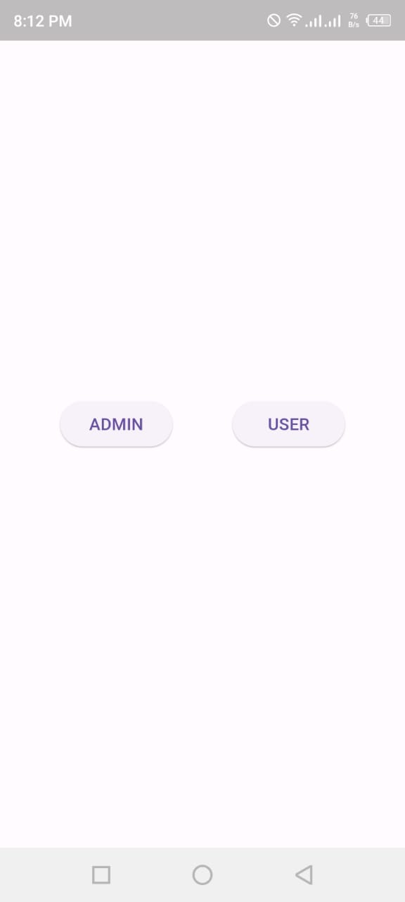

**Login Page.**

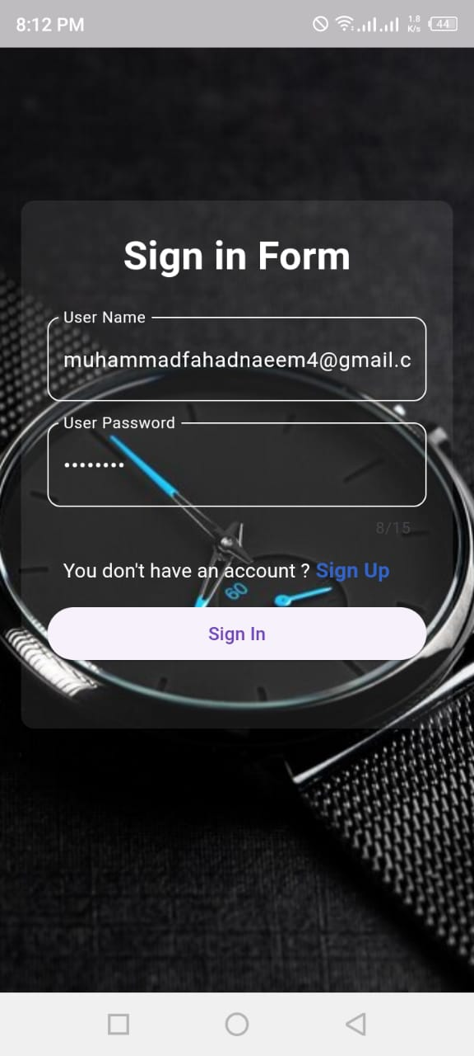

**Sign Up Page**

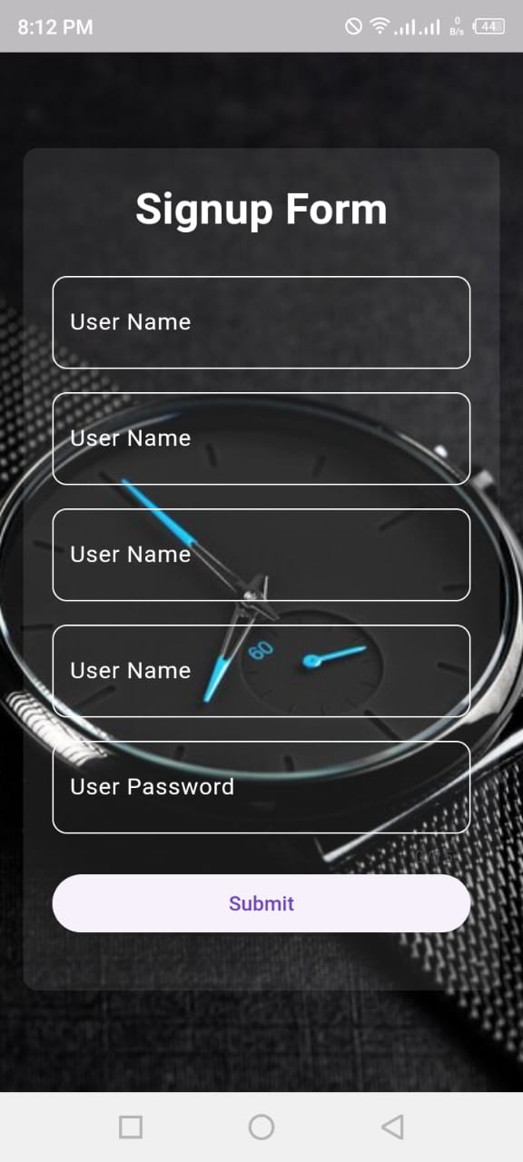

**Main Page.**

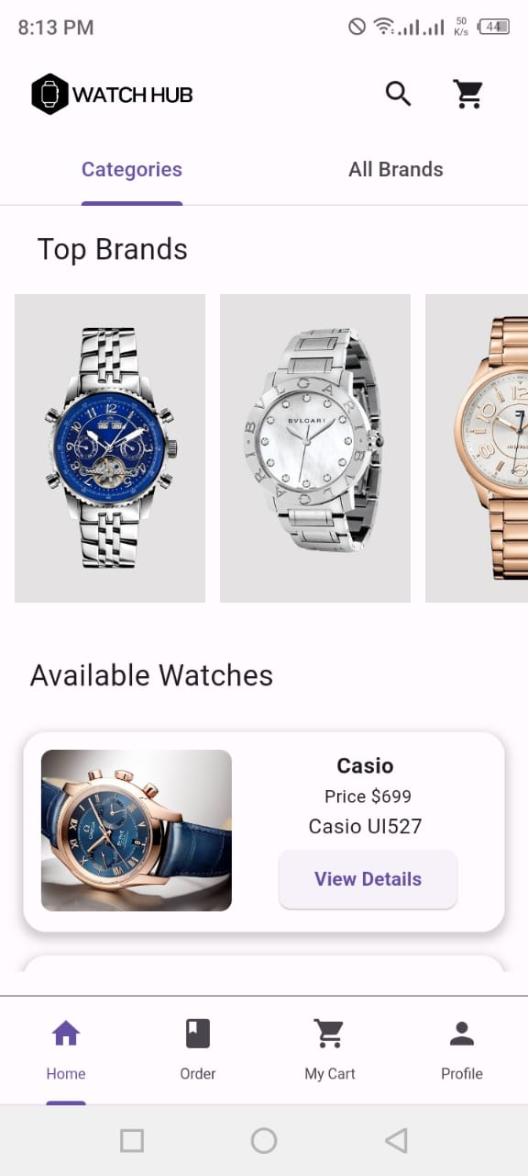

**Categories Page.**

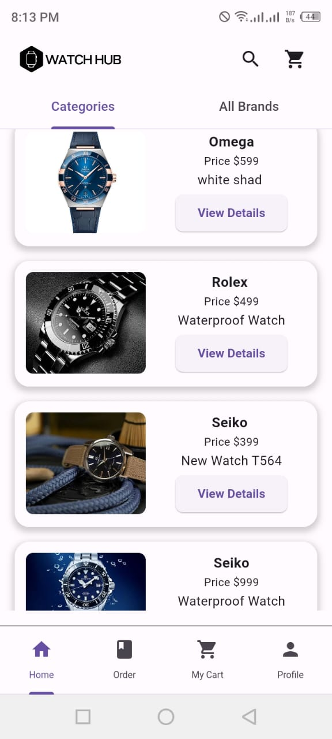

**All Brand Page.**

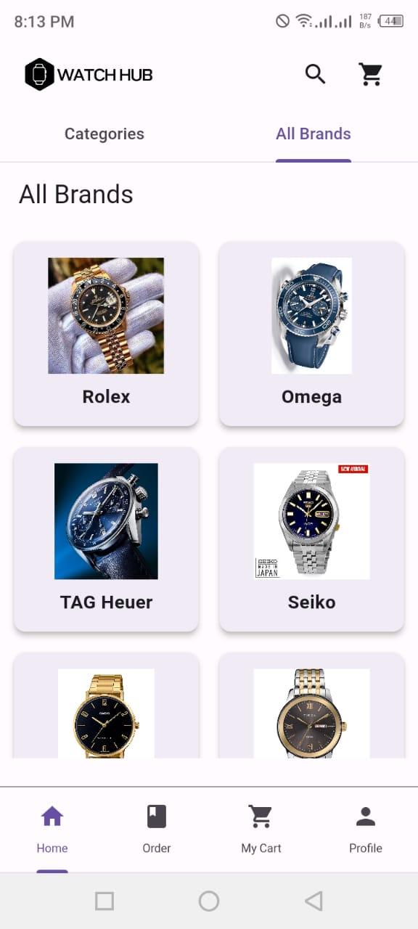

**Order Page.**

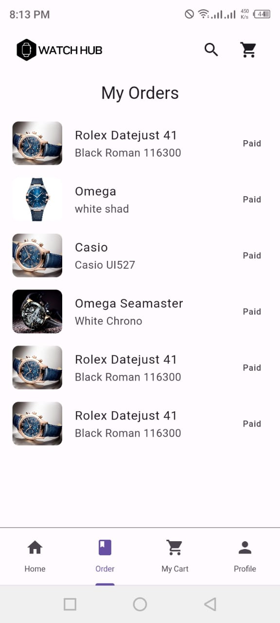

**Cart Page.**

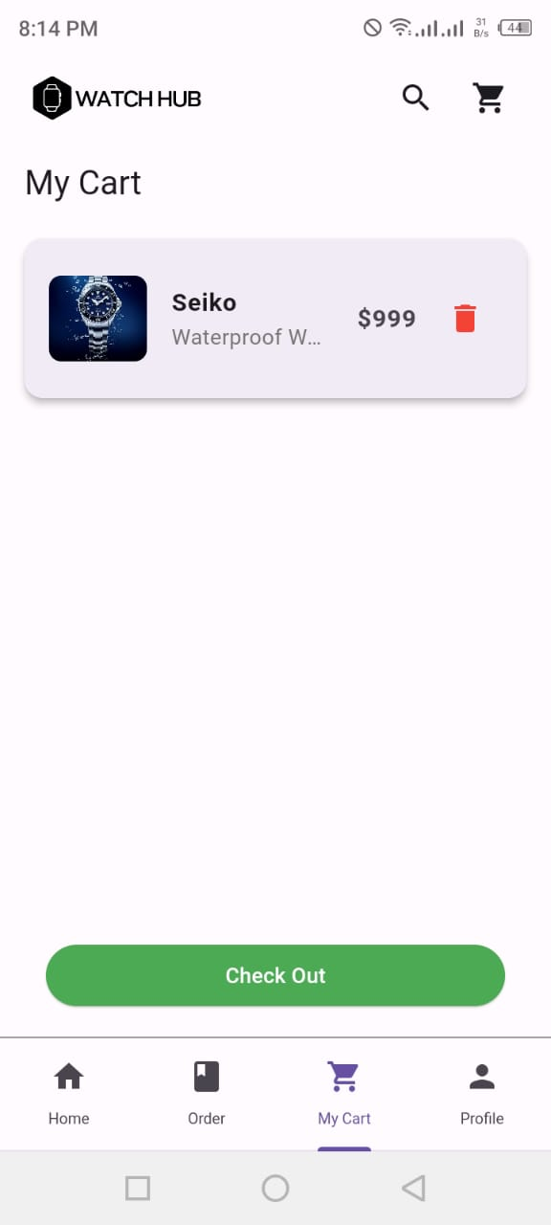

**Profile Edit Page.**

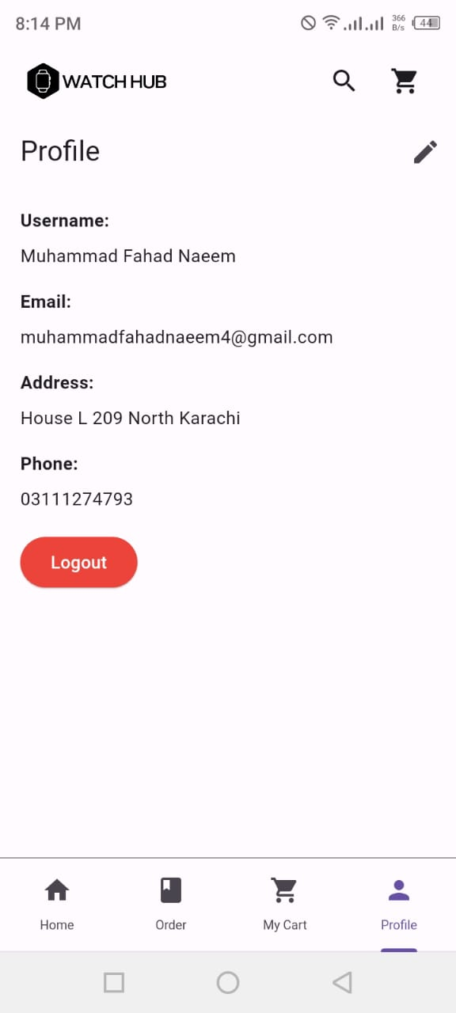

**Admin Product Add Page.**

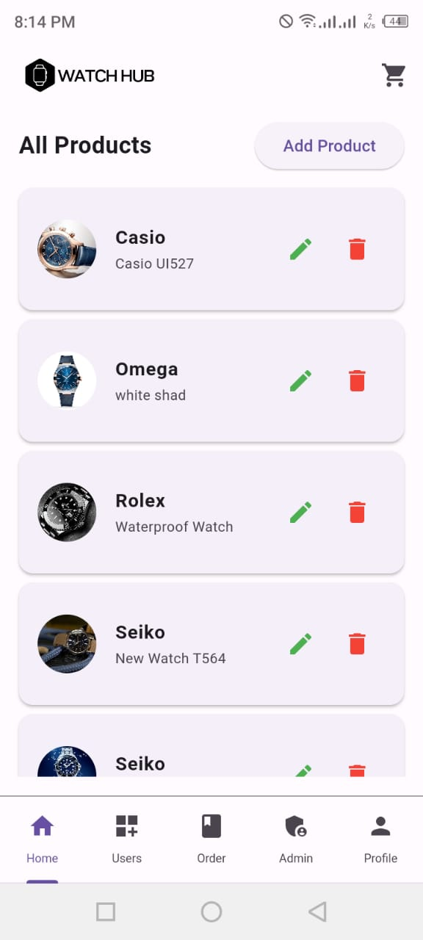

**Product Add Form.**

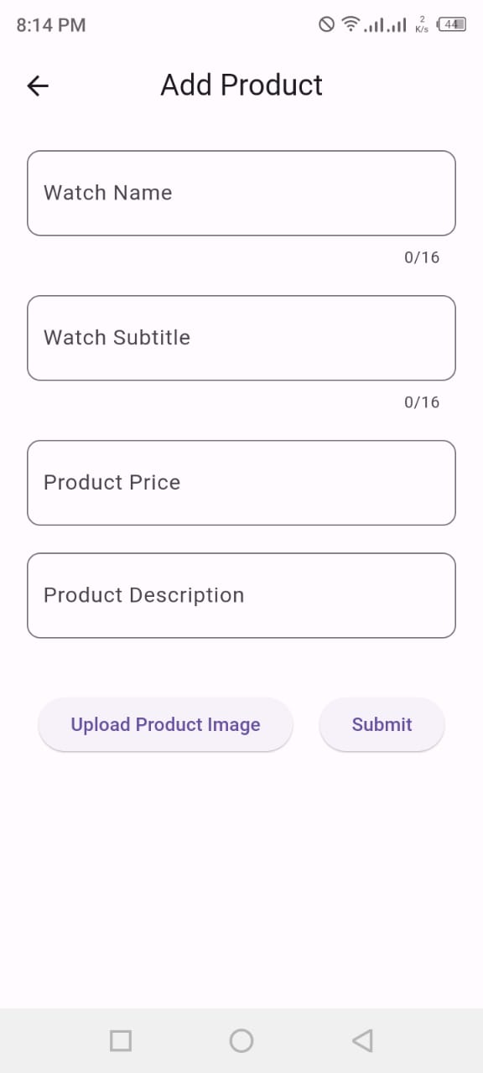

**User Detail Page For Admin.**

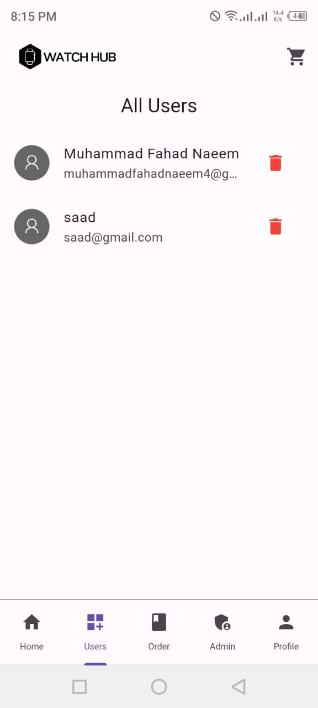

**END**